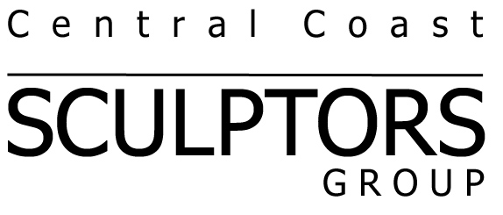
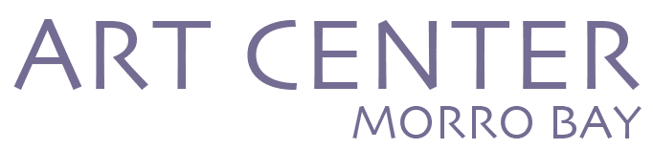

artcentermorrobay.org

CentralCoastSculptors.org

Call for Entry
Occupies Space
at Art Center Morro Bay
One definition of sculpture is: "That which Occupies Space in an interesting fashion.”

ENTRY DEADLINE:
Sunday, January 19, 2020
A Juried Exhibition presented by Central Coast Sculptors Group, affiliated with San Luis Obispo Museum of Art. Occupies Space will be held simultaneously with The Painters Group Brushstrokes 2020 exhibition.
Exhibition Dates: April 2 - May 11, 2020
Opening Reception: Sunday, April 5, 2020, 2-4 PM
Entry Deadline: Sunday, January 19, 2020, 11:59 PM
Eligibility: Occupies Space is a non-themed exhibition of Central Coast Sculptors Group, representing a wide range of artistic expression in sculpture. Occupies Space is open to members in good standing of Central Coast Sculptors Group, San Luis Obispo Museum of Art (SLOMA), or Morro Bay Art Association.
Note: Entries will be submitted and processed through the SLOMA website, but Occupies Space will be hosted at Art Center Morro Bay, 835 Main Street, Morro Bay, California.
Juror: TBD

Awards: Three sculptures will be chosen each to receive a Juror’s Award of Excellence and $250..

Submission Details: The Juror will select paintings from digital images supplied by artists via online submission only. Eligible artists may submit images of 1-2 sculptures for a fee of $35, or 3 images of sculptures for $45. Entry fees are non-refundable. No more than two sculptures will be selected from any single artist.
Each JPEG image must be labeled with the sculpture title and dimensions (height first) and no artist’s name (e.g. BlueSky.16x20x40.jpg.) Images should be a minimum of 600X900 pixels and no larger than 1800 pixels on the longest side.
To enter Occupies Space, go to the San Luis Obispo Museum of Art’s website, www.sloma.org, to Call For Entry: Occupies Space and follow the instructions in the SLOMA entry process. You will be asked to provide contact information, submit your images, and pay via credit card (Visa, MasterCard, or American Express). Please keep a copy of this application for your records.
Notification of acceptance or non-acceptance will be made via e-mail by February 3, 2020.
Agreement: Submission of artwork to this exhibition constitutes an agreement to the conditions stated in this Call For Entry and a commitment to show accepted art for the duration of the exhibition. If an artwork is sold, the purchaser can remove it upon proof of payment. The artist can replace the sold artwork with one of similar quality, if desired. By entering this exhibition, artists agree to allow CCSG, SLOMA, and ACMB to use submitted images in promotional material.
The Juror and TPG representatives reserve the right to reject any sculpture that does not meet the standards shown in the images supplied. No substitutions are allowed.
Requirements: Sculptures previously exhibited at SLOMA, ACMB, or in any past exhibition of CCSG are not eligible. Sculptures previously exhibited in the Phantom Project are eligible. All sculptures must be free-standing or pedestal mounted. No wall mounted sculptures can be selected, as the walls will have Brushstrokes 2020 paintings installed.
Sculptors must supply any special mounting facilities or a pedestal for their artwork. If you need a pedestal, some may be available from CCSG. Please contact Carl Berney at 505-690-4283 if you need a pedestal.
The gallery at ACMB is on the second floor. It is up a 30” wide stairway. There is no elevator. Please arrange for help if needed to carry your sculpture up the stairs.
Prices, Sales, and Commission: All paintings must be for sale. ACMB will handle all sales and retain a 25 percent commission. Artists will receive 75 percent of the sales price of the work. Prices set by the artists may not be changed after entry.
Insurance and Care: Artists are encouraged to carry their own insurance. ACMB and Central Coast Sculptors Group representatives will make every reasonable effort to protect artwork from the time it is received until it is returned to the artist. CCSG, ACMB and their representatives will not be held responsible for any damage or theft of artworks.
Delivery: Accepted sculptures must be hand delivered to Art Center Morro Bay, 835 Main Street, Morro Bay, CA 93442 on Tuesday, March 31, 2020 between 10 AM and 2 PM. No shipping is allowed for this exhibition.
Pick Up: Unsold paintings must be picked up on Tuesday, May 12, 2020, between 10 AM and 2 PM.
Information: For further information, contact Carl Berney at Sculpto707@gmail.com.
Exhibition Checklist:
Exhibition Dates: April 2 – May 11, 2020
___ Entry Deadline: Sunday, January 19, 2020, 11:59 PM.
___ Notification: Monday, February 3 , 2020.
___ Delivery: Tuesday, March 31, 2020, 10 AM – 2 PM.
___ Exhibition Opens, Thursday, April 2, 2020, 12 PM.
___ Reception: Sunday, April 5, 2020, 2 PM – 4 PM.
___ Pick-up: Tuesday, May 12, 2020, 10 AM – 2 PM.

